Edinburgh Napier University
Parking Payment Quick Guide: Permit Holders

Step 1: Edinburgh Napier Parking Permit
- If you have an existing parking permit you must pay to park via RingGo.
- If you are unsure whether or not you have a permit email car.parking@napier.ac.uk
- If you do not have a permit you must apply. You cannot park on campus until your permit is approved and confirmed. Issue of a permit may not be immediate, there may be a waiting list.

Step 2: RingGo Account
- RingGo is a commonly used payment system for parking. For example, RingGo is used by the City of Edinburgh Council and Glasgow City Council for payment of on-street parking.
- Using RingGo supports hybrid working and allows for flexible payments. Permit holders have the option of paying for one day, one week or one month of parking. However, please note that parking payments are not transferrable between vehicles. Parking payments are non-refundable.
- If you don’t have a RingGo account visit www.ringgo.co.uk You can also download the RingGo app through Google Play or the App Store. You will need a payment card to set-up your account.
- Once your RingGo account is set-up you can pay for parking through the RingGo App, website www.ringgo.co.uk or by calling 020 3046 0010. You cannot pay for parking within the University.

Step 3: Paying for Parking
- You will need your individual RingGo code that you received from car.parking@napier.ac.uk
- If you have not received a RingGo code please contact car.parking@napier.ac.uk
- See below for images of how the RingGo App and www.ringgo.co.uk will look when you pay.
- You will have the option to pay for one day, one week or one month.
- You can leave and return to campus as many times as you want within the selected time period.
- You will receive notifications through RingGo reminding you when your parking session will end.
- It is your responsibility to ensure that you have paid whenever you park your vehicle on campus.
- If you do not pay for parking, you may be issued with a parking charge notice.

Step 4: More information
- For more information including frequently asked questions visit the Property & Facilities pages within the Staff Intranet (Campus Life / Travel and Transport / Parking).

RingGo App

A: Download B: Enter your code then pay. Your code will save within ‘recent’.

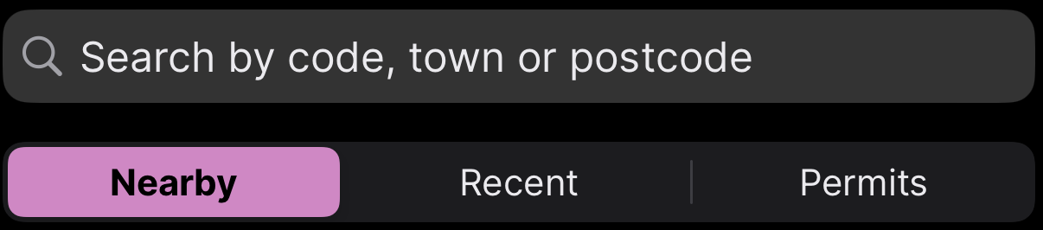
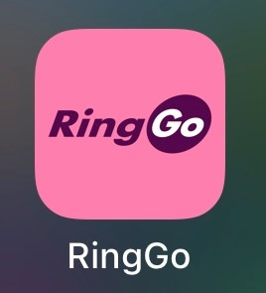
RingGo Website www.ringgo.co.uk

A: After logging in, click on ‘new session’ at the top right hand side of the welcome page.

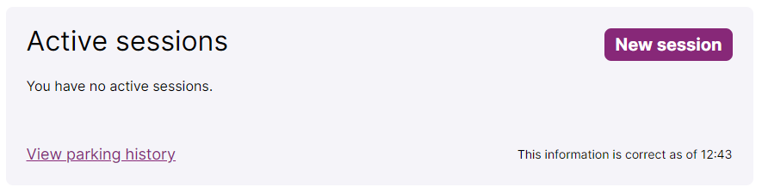

B: On the next page click on ‘create a new session’.

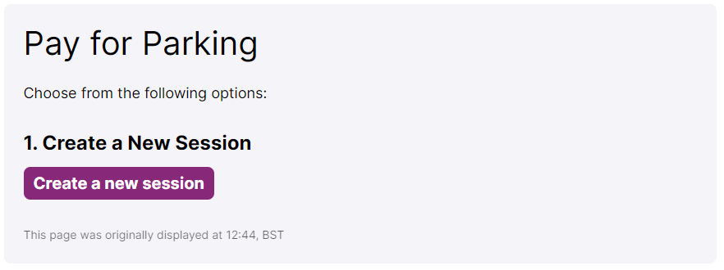

C: Enter your RingGo code.

