Accessing emails and Microsoft Teams on a personal Android device

Version control 1
Introduction 1
Install Intune Company Portal (if you don’t have it already) 1
Log into Microsoft Outlook 1
Sign into Microsoft Teams 3
Sign out of your corporate Outlook and Teams accounts 4
Sign out your corporate Outlook account 5
Sign out your corporate Microsoft Teams account 5
Good to know 5
Core Microsoft applications 5

Version control
Version no. | Summary of changes | Date
v0.1 | Document created | 20/01/2026
v0.2 | Addition of screenshots and how to sign out | 22/01/2026

Introduction

To protect Edinburgh Napier data, only access to core Microsoft apps is allowed when using a personal device.
This guide outlines how to sign into Microsoft Outlook and Microsoft Teams. It also describes how to sign out of these applications.

Please note that new Android versions are released regularly and the screenshots/instructions below may differ in future versions of the operating system (OS). Links to official documentation is provided throughout this guide.

Install Intune Company Portal (if you don’t have it already)
If you already have the Company Portal installed, you can skip steps 1 – 2.

- Open the Play Store and search for “Microsoft Intune Company Portal”.
- Download the app. You DO NOT need to sign in.

If you do not install the Company Portal at this stage, you will be prompted to do so later.

Log into Microsoft Outlook

- Open Microsoft Outlook or download it from the Play Store.
You can set up your Edinburgh Napier emails through the Outlook app only. Gmail app and any other mail client are not supported.
- To add your Edinburgh Napier account, click the “+” icon on the left hand-side and click “Add an account”.
- Enter your staff email address (X.XYZ@napier.ac.uk) and click “Continue”.
- Type in your Edinburgh Napier password and click “Sign in”. You may be asked to verify your identity through the usual Multi-Factor Authentication (MFA) method you use.
- \Click “Register”.
- The Intune Company Portal app will work in the background to check your device is supported and you are connected as expected. A green tick box will confirm everything is in order. Click “Continue”.
- If this is the first time you use one of the authorised applications on your device, you will be prompted to create an 8-digit PIN number to secure access to Edinburgh Napier data. If you have biometrics access set up on your device, you may be able to use it to unlock supported Edinburgh Napier applications.

This is dependent on your device and OS version. Information Services doesn’t have control over this.

You can access the most up to date guidance from the Microsoft official documentation here: https://support.microsoft.com/en-gb/office/set-up-email-in-the-outlook-for-android-app-886db551-8dfa-4fd5-b835-f8e532091872

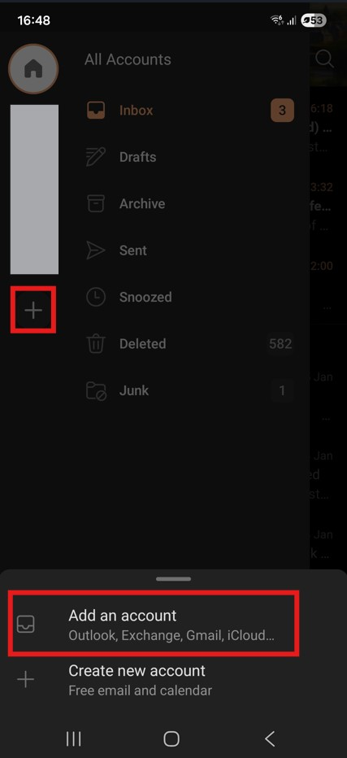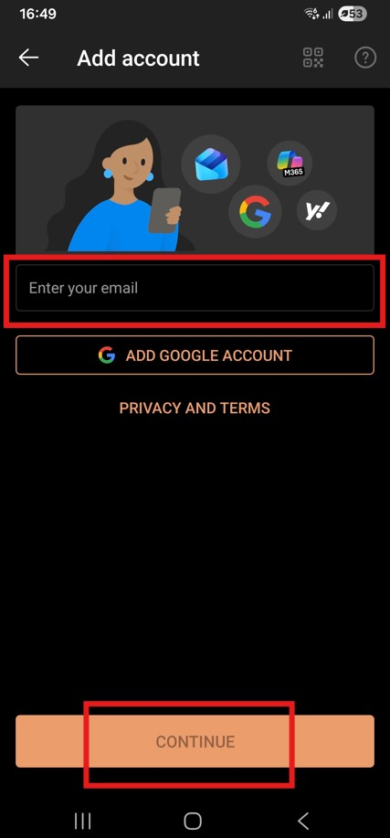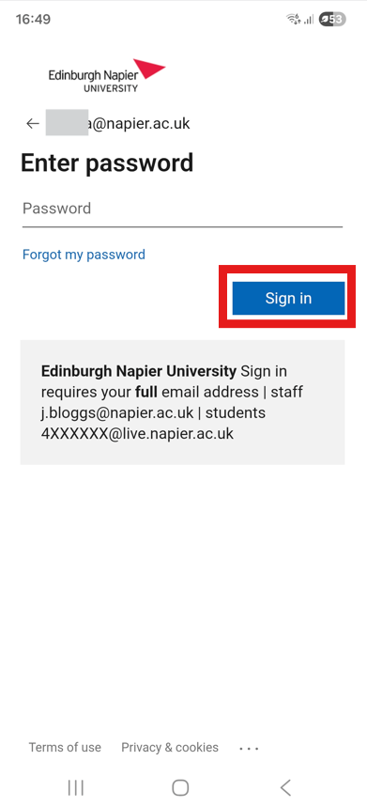

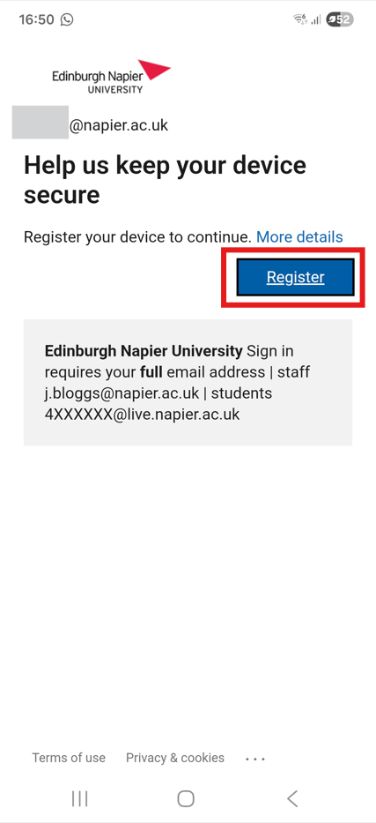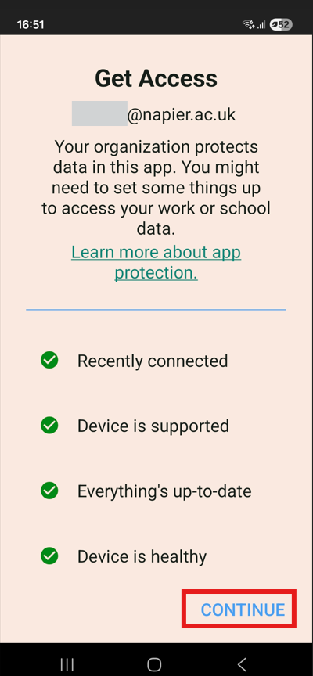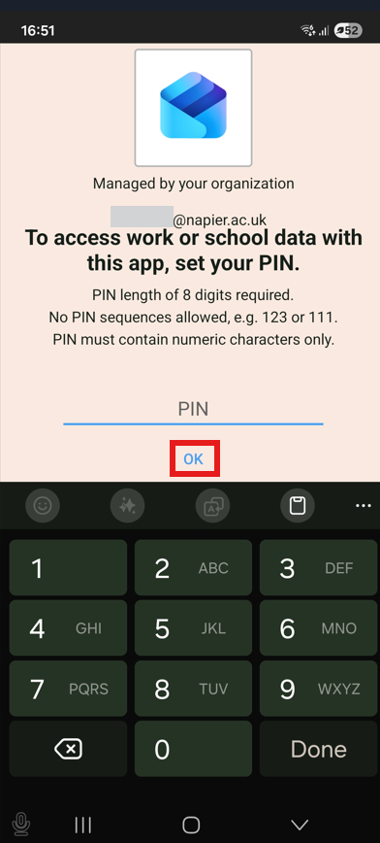

Sign into Microsoft Teams
- If not already installed, download the Microsoft Teams app from the Play Store
- Click “Create or use another account”
- Enter your staff email address (X.XYZ@napier.ac.uk) and click “Next”.
- Enter your Edinburgh Napier password and click “Sign in”. You may be asked to verify your identity through the usual Multi-Factor Authentication (MFA) method you use.
- The Intune Company Portal app will work in the background to check your device is supported and you are connected as expected. A green tick box will confirm everything is in order. Click “Continue”.
- If this is the first time you use one of the authorised applications on your device, you must provide an 8-digit PIN number to secure access to Edinburgh Napier data. If you have biometrics access set up on your device, you may be able to use it to unlock supported Edinburgh Napier applications.

This is dependent on your device and OS version. Information Services doesn’t have control over this.

You can access the most up to date guidance from the Microsoft official documentation here: https://support.microsoft.com/en-gb/office/sign-in-sign-up-sign-out-and-add-a-new-account-in-microsoft-teams-free-4c3734a1-f4ac-4da7-bd7d-5b69d6e3a9a3#id0efd=mobile
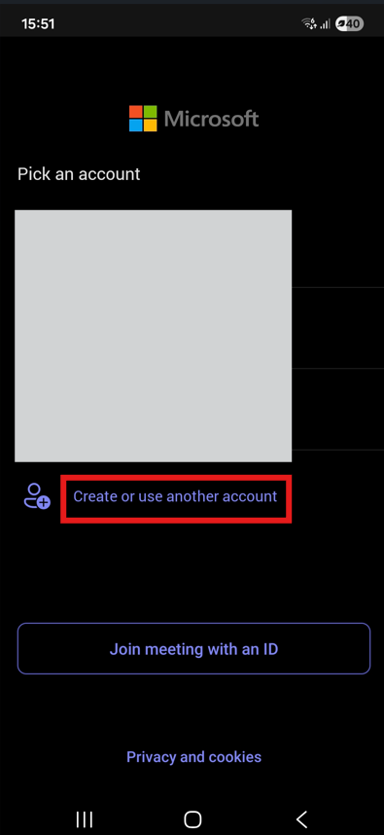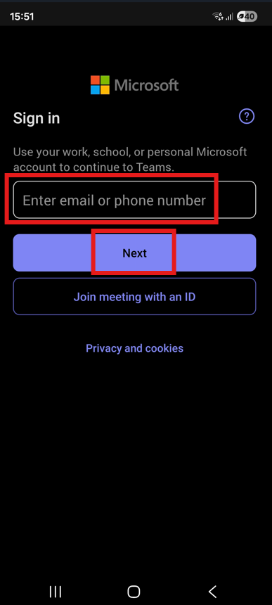

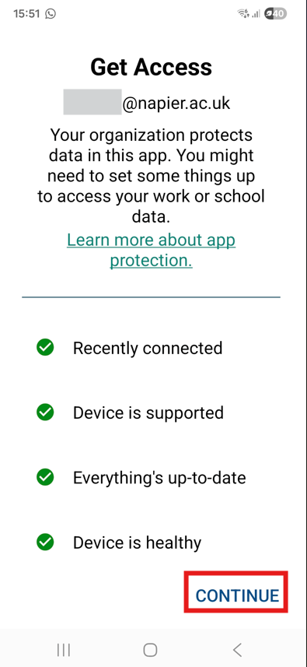

Sign out of your corporate Outlook and Teams accounts
If you don’t want to access your corporate emails and/or Teams messages from your personal device any longer, you can sign out of the apps.

Sign out your corporate Outlook account
- Tap the settings icon on the bottom left of the screen.
- Scroll down to “General” and click “Accounts”.
- Select your Edinburgh Napier account.
- Scroll to the bottom of the screen and click “Remove account”. This will simply remove your account from the Outlook app on your device. It will not delete your corporate account from your managed laptop.

You can access the most up to date guidance from the Microsoft official documentation here: https://support.microsoft.com/en-gb/office/sign-out-of-office-5a20dc11-47e9-4b6f-945d-478cb6d92071#:~:text=For%20Android%20or%20Chromebooks%3A,Sign%20Out%20again%20to%20confirm.

Sign out your corporate Microsoft Teams account
1. Tap your profile icon.
2. Select “Settings”.
3. Scroll to the bottom and click “Sign out”.

You can access the most up to date guidance from the Microsoft official documentation here: https://support.microsoft.com/en-gb/office/sign-in-sign-up-sign-out-and-add-a-new-account-in-microsoft-teams-free-4c3734a1-f4ac-4da7-bd7d-5b69d6e3a9a3#id0efd=mobile

Good to know

To protect yours and the University’s data, there are some restrictions in place which should not impact your work:

- Screenshots and capturing data via assistants will be blocked.
- You cannot copy data outside of core Microsoft apps. You can however:
  - paste data between core Microsoft apps;
  - paste photos and files stored on your mobile;
Any attempt to copy data to an unmanaged source (for example your phone’s notepad) will be blocked.
- If you uninstall the Intune Company Portal app, Edinburgh Napier data will be removed.
- Files cannot be saved directly to your local storage. If you need to save files, please ensure you have installed and signed in to Microsoft OneDrive.
- Limited / anonymised push notifications to protect University information.

Core Microsoft applications
You are also able to download and login with your Edinburgh Napier account into the following applications: Microsoft 365 Copilot, Edge, Excel, OneDrive, OneNote, Outlook, PowerPoint, SharePoint, Teams, To-Do, Word.
The files will be synched across your devices.

