Why have I received this leaflet?
This is being shared with you because your programme is about to go through Institution-Led Review (ILR), one of the University’s formal quality assurance and enhancement processes, and we would like you to be involved.

It is a University priority to engage with students as partners in shaping the direction of learning and teaching. One of the ways the University does this is by involving students in Institution-Led Review. This provides an opportunity for your lecturers, and other staff across the University to hear about your experience on your programme and to involve you in making improvements and sharing things that you think work well.

What is Institution-Led Review?
Every taught programme at the University is subject to review every 6 years (in line with Scottish Funding Council expectations and the requirements of the UK Quality Code for Higher Education). At Edinburgh Napier, this is called ‘Institution-Led Review’. It is an ‘enhancement-led’ approach to review, meaning it is not about finding problems or criticizing individuals, but is about continuous improvement, and celebrating and sharing good practice.

Institution-Led Review determines:
- whether the programmes meet the required academic standards for the award;
- that the approaches to learning, teaching and assessment enable students to achieve the learning outcomes and;
- that the programmes provide students with access to high quality learning experiences.

Our approach at Edinburgh Napier has been informed by the Student Partnerships in Quality Scotland (sparqs) Student Learning Experience model:
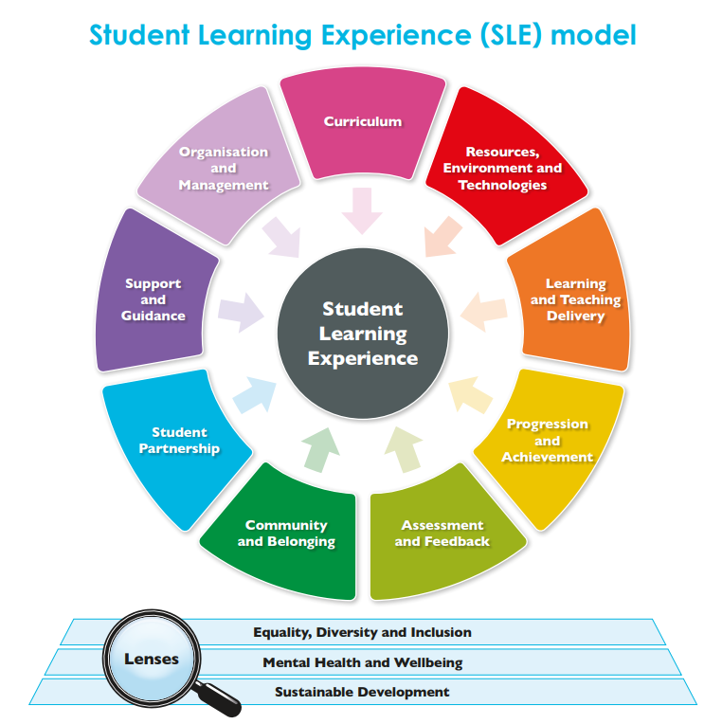

What happens at the review?
Your programme leader will contribute to the production of a Self-Evaluation Report about the programmes in your area of study. This, together with other information relating to the programme (such as programme reports, Moodle pages, module evaluations and NSS results) will be made available to a panel of academics and professional services staff from Edinburgh Napier, a student panel member from a different subject area to the programmes under review, and a subject expert from another University or from industry. An event then takes place over 1-2 days at which the panel considers the information provided, then meets with lecturers and students on the programme before deciding a review outcome.

What does the review team want to know from students?
There are a number of things a panel may cover with students, depending on the information provided to the panel in advance. These are likely to include:
- Student involvement in preparing for the review.
- Opportunities for work placement, links with industry, and study abroad.
- Opportunities for students to provide feedback about the programme and your wider experience at the University how the feedback loop is closed (you may be asked for an example of an issue raised and action taken).
- Your experiences of assessment, including feedback on assessment performance.
- Support for learning and personal development, such as personal development tutors, volunteering, and resources, such as access to technology or software.
- Experiences of different student groups such as distance learners, direct entrants from college or students studying at partner institutions overseas.
- Anything you would single out as particularly good about the programme.

What’s in it for you and how will you be supported?
Contributing to the review will give you an opportunity to build your network of contacts among fellow students and staff, experience of a professional review panel, and a unique insight into the University’s quality assurance and enhancement processes. It is an opportunity to enhance the quality of the educational experience at Edinburgh Napier, and to contribute to a national process of ensuring the quality of Scottish university education.

How to get involved
There are a number of ways you can get involved:
- Through your School’s Student-Staff Liaison Committee (SSLC) or Board of Studies;
- Become a programme rep or speak to your current reps about how you can help;
- Participate in focus groups/student meetings and respond to questionnaires;
- As a rep you may be asked to give feedback on the Self-Evaluation Report;
- Participate in the review by attending and meeting with the panel (you will be briefed in advance);
- With the academics on the programme, consider the review outcomes and actions.

If you would like to be involved in the review of your programme, please get in touch with your programme leader and student rep(s).

Further information:
- The Quality Framework, Section 2b, Institution-Led Review: http://staff.napier.ac.uk/services/dlte/quality/qualityframework
- sparqs (student partnerships in quality Scotland): Engaging students in Institution-Led Review – a practice guide for universities and SAs (available from https://www.sparqs.ac.uk/)
- sparqs Student Learning Experience Model - SLE_model_digital_resource.pdf (sparqs.ac.uk)
- Quality & Standards Team, DLTE: quality@napier.ac.uk

